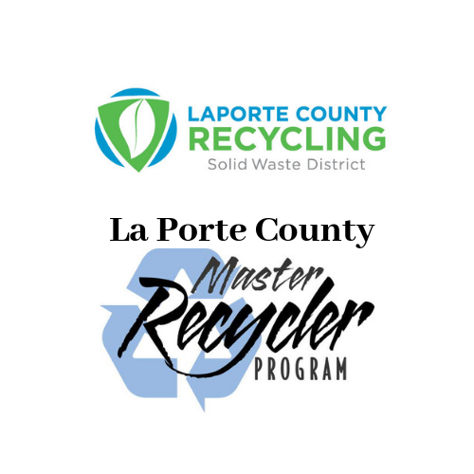
All classes will be held at the Solid Waste District Office, 2857 W. State Road 2, La Porte, beginning May 11th from 1-3 pm
- May 11th - Introduction, the history and future of waste

- May 18th -Waste flow process

- May 25th -Organic waste reduction

- June 1st -Hazardous waste

- June 8th - Graduation and Enviro-Jeopardy

Participants that miss more than one classroom date will not complete the course and will not graduate.

Signups are now in progress. For more information call our office 219-326-0014 or email Sacha at sgeeburns@solidwastedistrict.com

