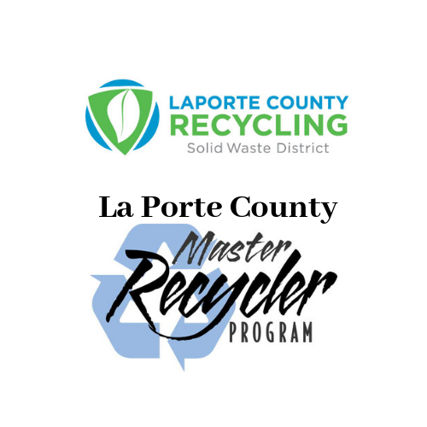
All classes will be held at the Solid Waste District Office, 2857 W. State Road 2, La Porte, from 1:30-3:30pm from May 20th- June 24th
- May 20th - Introduction, the history and future of waste

- May 27th -Waste flow process

- June 3rd -Organic waste reduction

- June 17th -Hazardous waste

- June 24th - Graduation and Enviro-Jeopardy

Participants that miss more than one classroom date will not complete the course and will not graduate.
Field Trips (optional but encouraged)
Homewood Star Disposal Recycling Facility
Pratt Industries
East Berrien County Landfill
Tradebe
Vexor Engineered Fuel

Signups are now in progress. For more information call our office 219-326-0014 or email Sacha at sgeeburns@solidwastedistrict.com

